Chapter 16, Solution 54.

The switch in Fig. 16.77 has been in position 1 for t < 0. At t =0, it is moved from position 1 to the top of the capacitor at t = 0. Please note that the switch is a make before break switch, it stays in contact with position 1 until it makes contact with the top of the capacitor and then breaks the contact at position 1. Determine v(t).
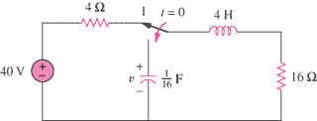

Figure 16.77
For Prob. 16.54.

Solution

Step 1. First determine the initial conditions and then transform the circuit into the s-domain and solve for V. Then perform a partial fraction expansion and then find v(t). We will assume that the value of v(0) = 0. i_{L}(0) = 40/20 = 2 amps.

16 Ω

4s

2/s

+

V

−

I

16/s

[16/s]I + [4s](I–2/s) + 16I = 0 and V = [16/s](–I).

Step 2. [(16/s)+4s+16]I = [4(s²+4s+4)/s]I = 8 or
I = 8s/[4(s+2)²] = 2s/[(s+2)²] and V = –32/[(s+2)²]

v(t) = [–32te^{–2t}]u(t) volts.

